NAME: ARUNAVA DEY
ROLL NO: 11500117123

1. running shell script

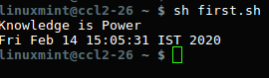

2. printing variables’ name

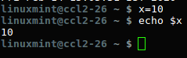

3. adding two numbers

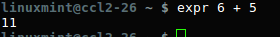

4. evaluating expression through user defined variables

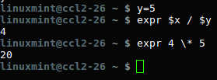

5. Printing specific lines from a file

